

Sri Lanka Institute of Information Technology

Programming Applications and Frameworks - IT3030

**Initial Document**

GROUP ID: JUNE-WE-89

Kumara J. K. S. U – IT22179180

Nikeshi V. G. N – IT22027092

Gunawardana N. N – IT22335814

Nugaliyadde S. N – IT22355164

**Content**

1. Project Description
2. The functional requirements for the REST API and the client web application

2.1 REST API

2.2 Client Web Application

1. The non-functional requirements for the REST API and the client web application

3.1 REST API

3.2 Client Web Application

1. Overall architecture diagram for the entire system
2. Architecture Diagram for REST API
3. Architecture Diagram for Client Web Application
4. References

**1. Project Description**

The project's objective is to establish a social media network where enthusiasts of coding may exchange programming projects, learning experiences, and other tech-related material. The site will allow users to offer tutorials, follow other users, share code snippets, make accounts, and contribute videos or pictures of their work. Additionally, they are able to evaluate and suggest educational materials, programming classes, and coding challenges. The goal is to create a vibrant developer community that encourages cooperation and skill growth by connecting, motivating, and learning from one another's coding experiences.

There are four main functions that related to our web application

1. User Profiles and Social Connectivity Management
2. Post Management in learning platform
3. Social Media Post Creation and Like Management
4. Comments and Notifications Management
5. **User Profiles and Social Connectivity Management**

This function is the backbone of our skill sharing platform, ensuring seamless user interactions. Authentication secures user access through registration, login, and session validation while supporting password updates and logout functionality. Profile Management empowers users to create and maintain their personal information, including bios and profile pictures, while enabling profile searches. Following Management fosters connections by allowing users to follow or unfollow others and view their networks. Dashboard enhances engagement by enabling users to post, edit, and delete updates, as well as browse personalized feeds based on their connections. Together, these modules deliver a robust and user-friendly experience.

1. **Post Management in learning platform**

This system enables teachers to **publish new courses** by uploading **images** or **short videos**, making learning more engaging and interactive. Once a course is published, it becomes **immediately visible to students**, allowing them to explore and register. Teachers also have the ability to **create a structured learning plan** for each course, outlining key topics, milestones, and objectives. Students can **download the learning plan** to track their progress and follow a well-defined learning path. By providing a **seamless course publishing** and **learning plan management** experience, this system ensures an **efficient and structured** learning environment for both teachers and students.

1. **Social media platform post creation and like management**

The Post Management function enables users to create, update, and delete posts related to their skills, expertise and experiences. Lecturers can create and share posts to engage with the community. Lecturers can publish posts to attract students by sharing insights, learning opportunities, and skill development content. Posts can include text, images, links, and attachments to enhance visibility and engagement. Users can interact with posts by liking, commenting.

**4.Comment & Notification Management**

The Comments & Notification Management function enhances user engagement by enabling commenting on group posts and providing real-time notifications. Users can add, view, edit, and delete comments while staying informed about discussions, replies, and group activities. Admins receive alerts for membership requests and reported content, ensuring effective communication and moderation.

**2. The functional requirements for the REST API and the client web application**

2.1 - REST API

• Users should be able to create, view, update, and delete their posts.

• Users should be able to register through new accounts.

• Users should be able to view their personal profile.

• The owner of the post should be able to delete any comments.

• Users should be able to add likes to posts.

• Users should be able to follow other users.

• Users should be able to edit their personal account information.

2.2 - Client Web Application

• The application should enable users to search for specific data based on predefined criteria.

• The platform should be user-friendly.

• Can search user profiles.

• Notify users when they like or comment on our posts.

• When creating posts, you can add a maximum of four photos.

• Able to make Profile recommendations.

**3. The non-functional requirements for the REST API and the client web application**

3.1 - REST API

• The system should be accessible at any time of the day.

• The system should be able to handle many requests and the responses

• The information security should be there in this system

3.2 - Client Web Application

• There should be a clear and simple navigation structure inside the entire process.

• There should be a proper way to secure user’s data.

• There should be a cross-platform mechanism for this system to work on different browsers and operating systems.

**4. Overall architecture diagram for the entire system**

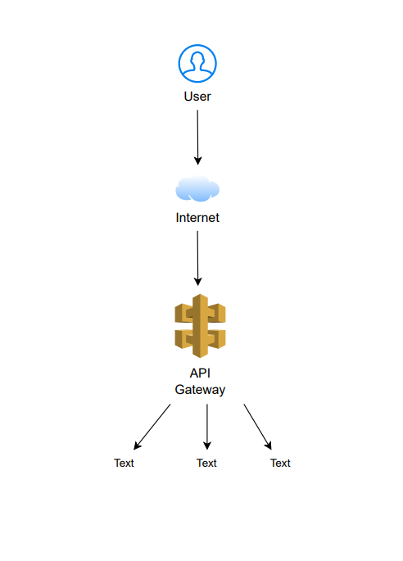

**5. Architecture Diagram for REST API**

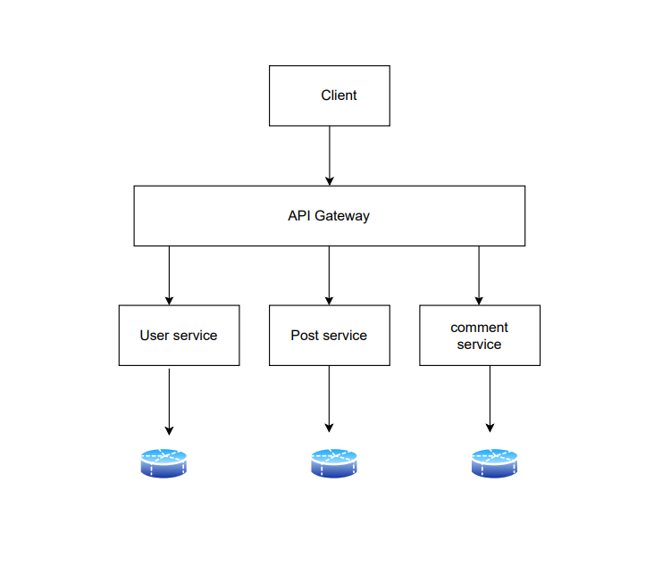

**6. Architecture Diagram for Client Web Application**

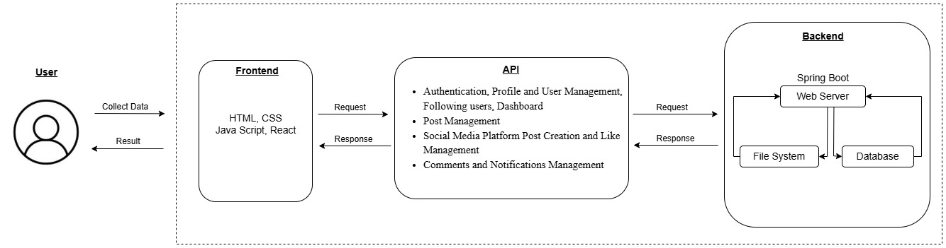

**7.Gantt chart**

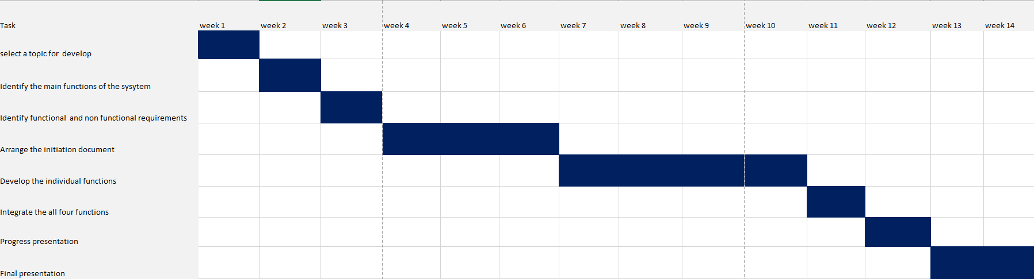

**7. References**

1. **Smart Draw – Draw Architectural Diagrams**

[**https://www.smartdraw.com/software/smartdraw-online.htm?srsltid=AfmBOoqfU3imDnYYQhkTdSwGGB2LYL2lpUfUbl187rlEJrdgkNlabh8V**](https://www.smartdraw.com/software/smartdraw-online.htm?srsltid=AfmBOoqfU3imDnYYQhkTdSwGGB2LYL2lpUfUbl187rlEJrdgkNlabh8V)

1. **Difference between client web application & client/server application.**

[**https://stackoverflow.com/questions/715063/what-is-the-difference-between-a-web-application-and-a-client-server-application**](https://stackoverflow.com/questions/715063/what-is-the-difference-between-a-web-application-and-a-client-server-application)